# The Flying Saucer Point of Sale Test

## Testing Adding the Flying Saucer to the Order

1. Open the application, you should see a window like this. 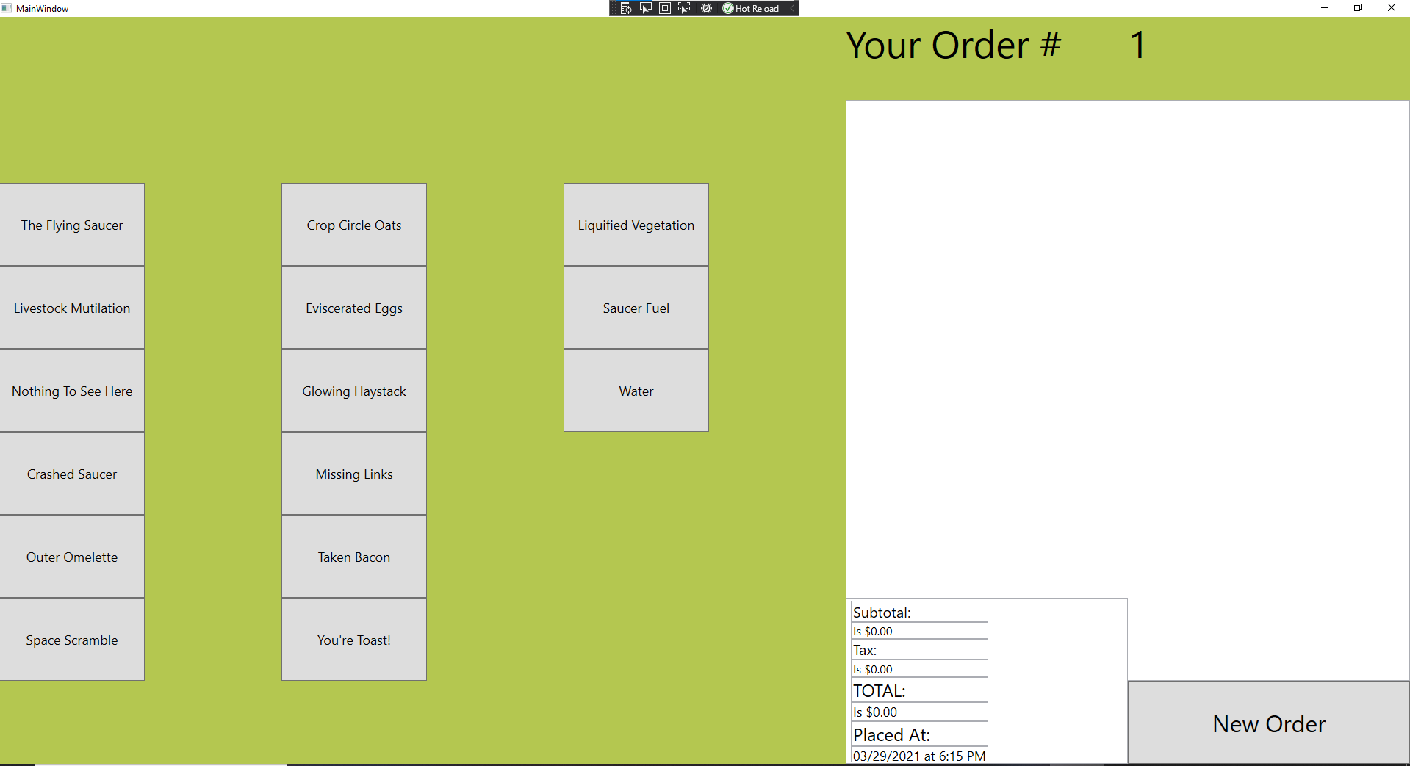
2. Click on “The Flying Saucer” customization button.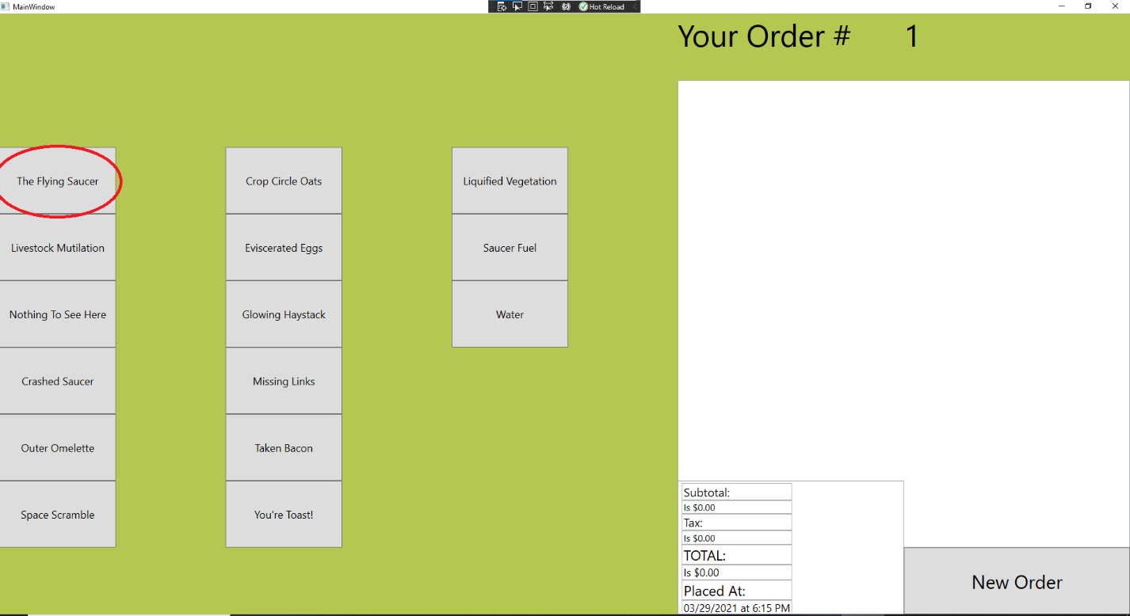
3. Your screen should now look like this. Verify that the Flying Saucer complete with calories, price and special instructions appear on the order screen. 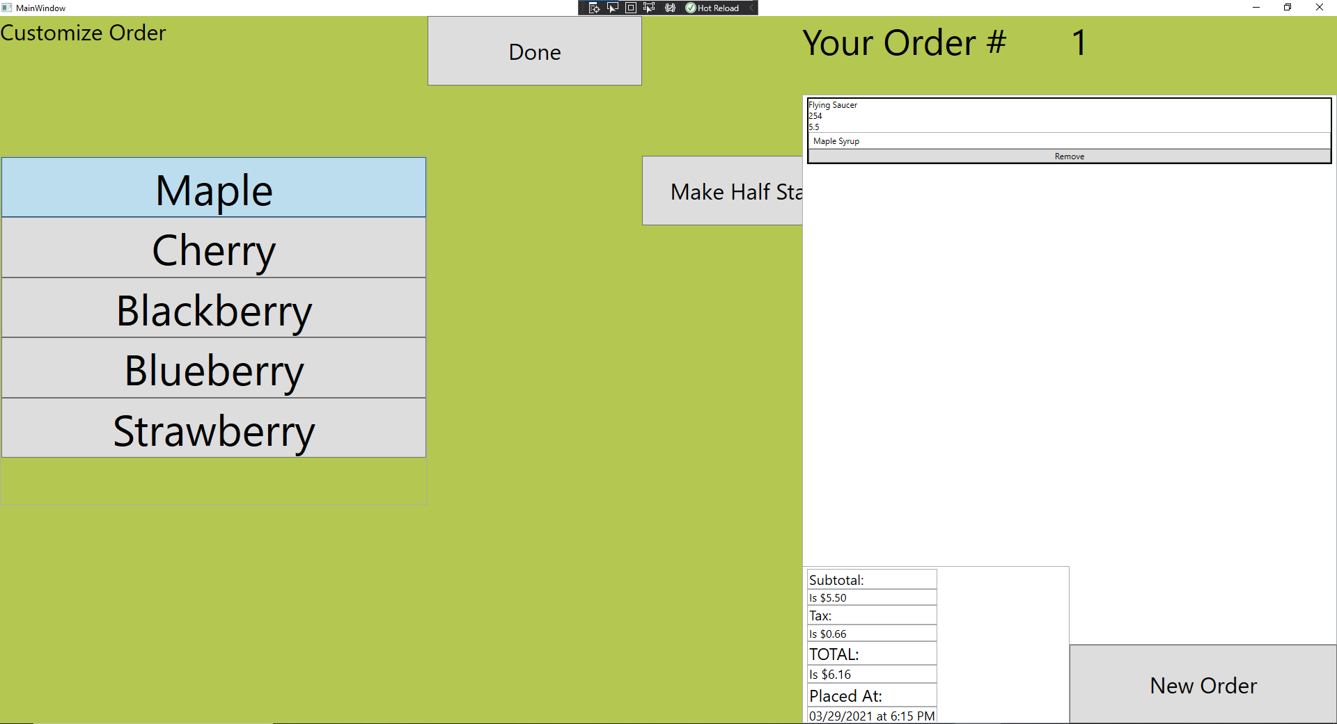
4. Select each of the syrup flavors, verifying that the special instructions on the order have changed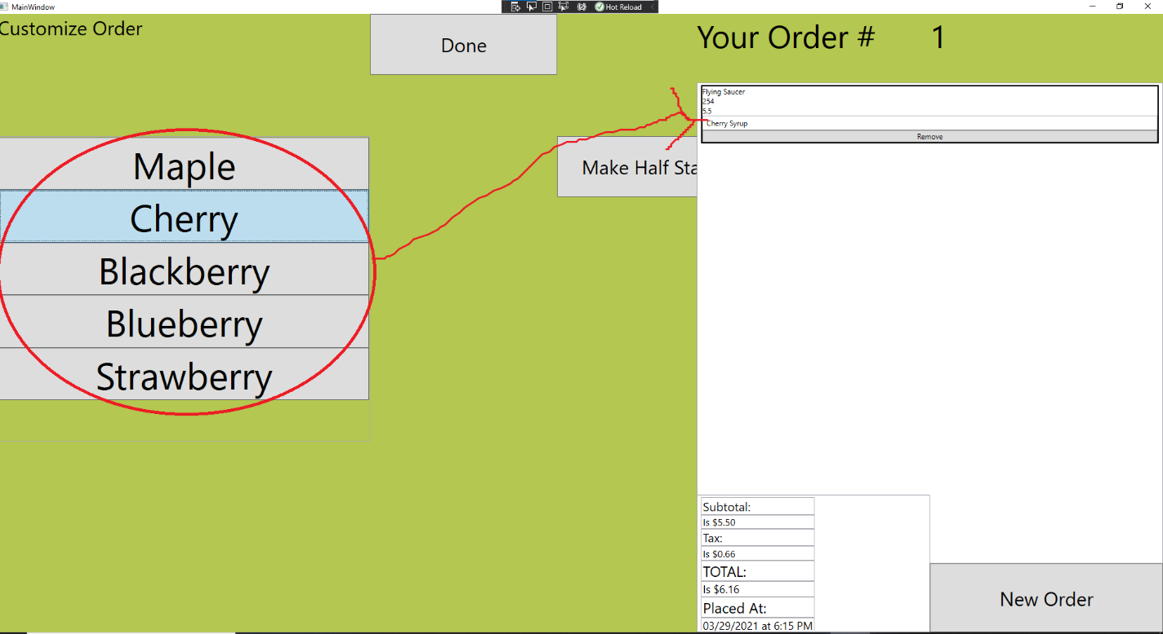
5. Select the Half-Stack option and verify that the following items on the screen change:

-Calories

-Individual item price

-Subtotal

-Tax

-TOTAL

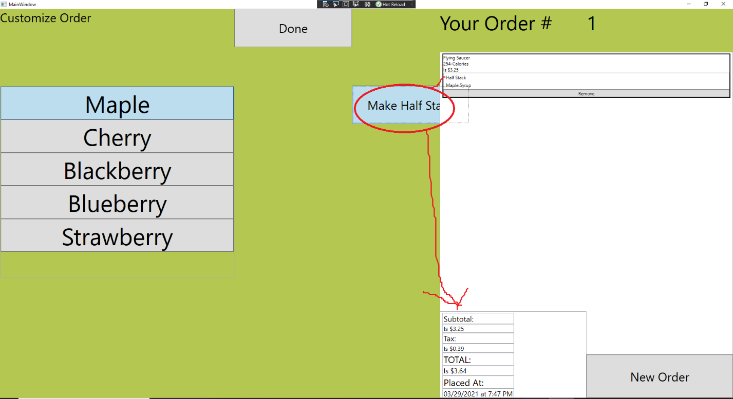

1. Click the “Done” button
2. Select the “Livestock Mutilation” Button

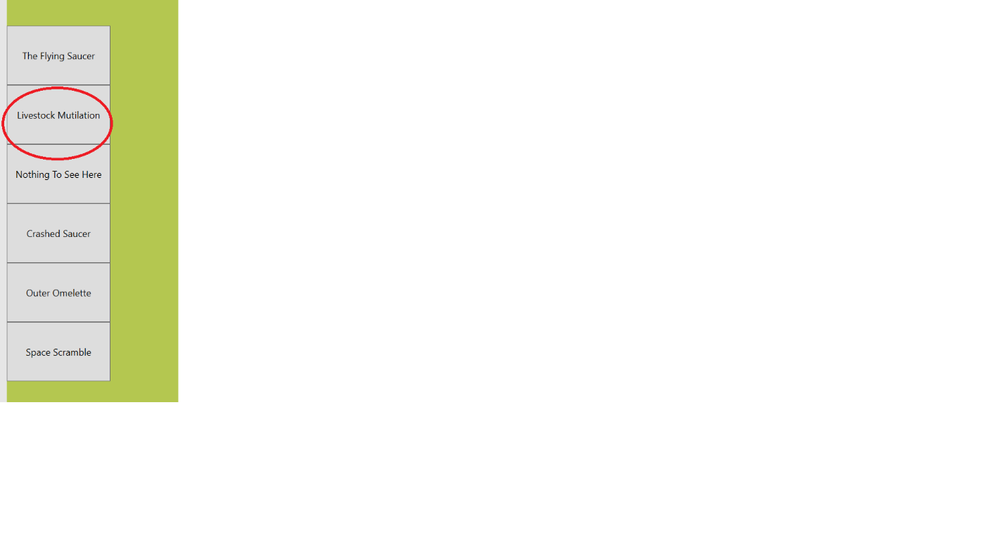

1. Like in step 3, verify that a Livestock Mutilation item appears on the Order Menu.
2. Click the “Gravy on the Side” option and verify that special instructions have changed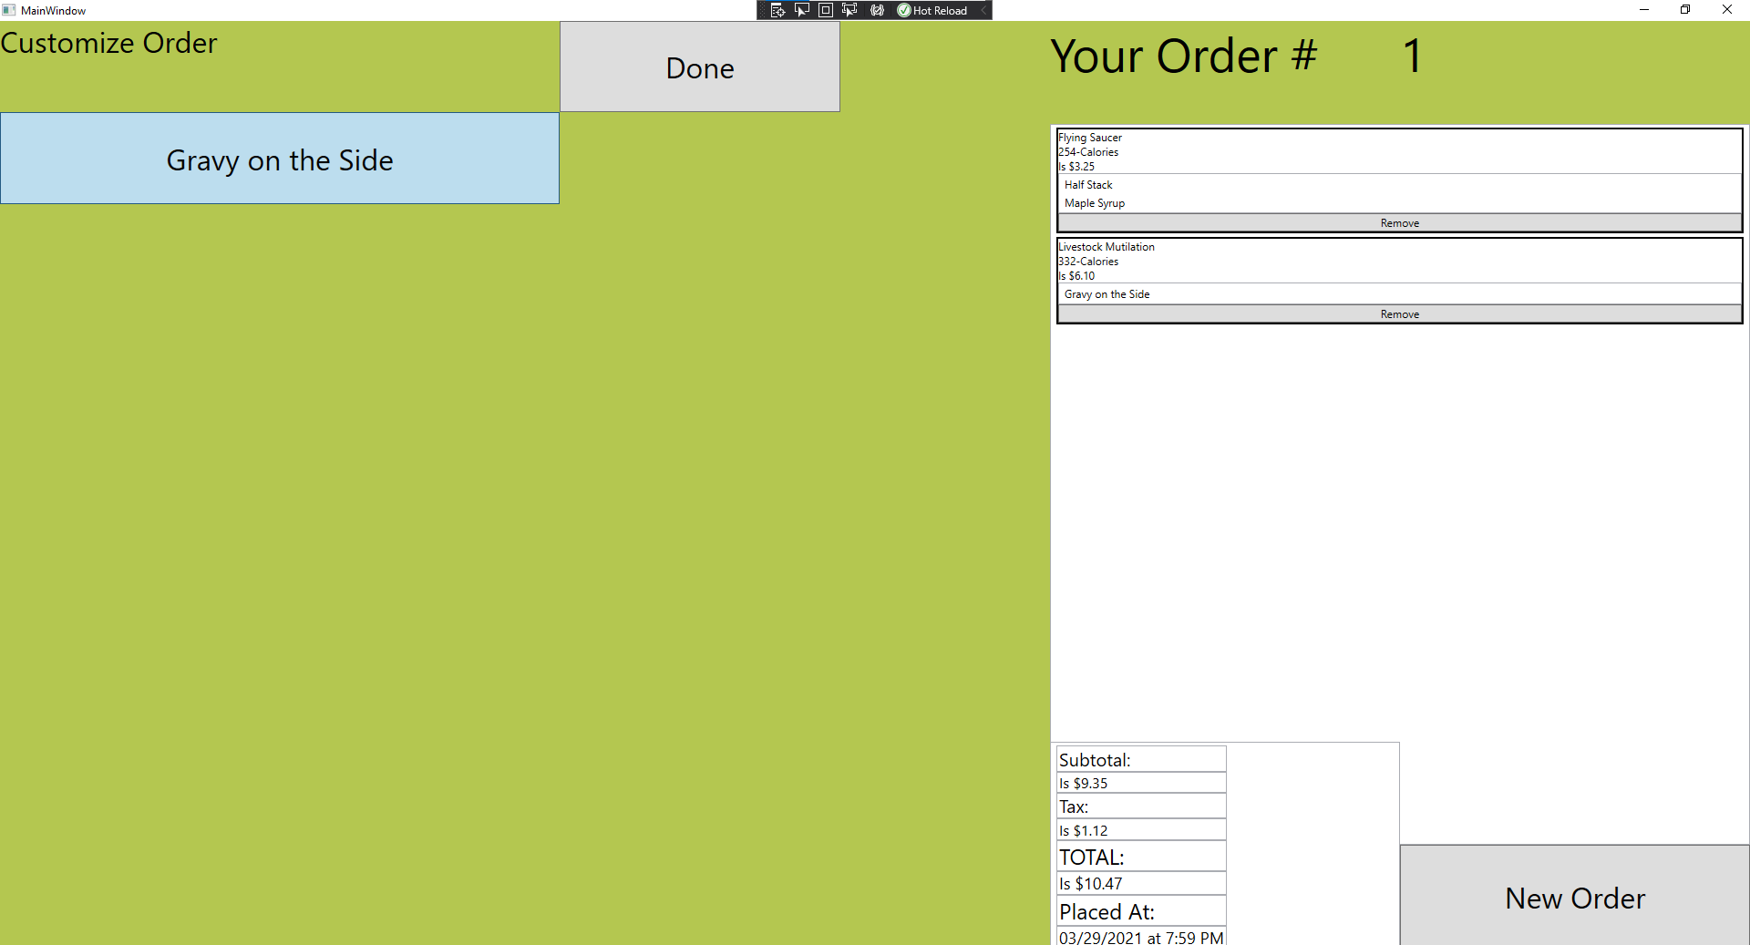
3. Click the “Done” button to return the Main Menu
4. Click the “Nothing to See Here” button on the Main Menu
5. Verify that your screen looks as follows:

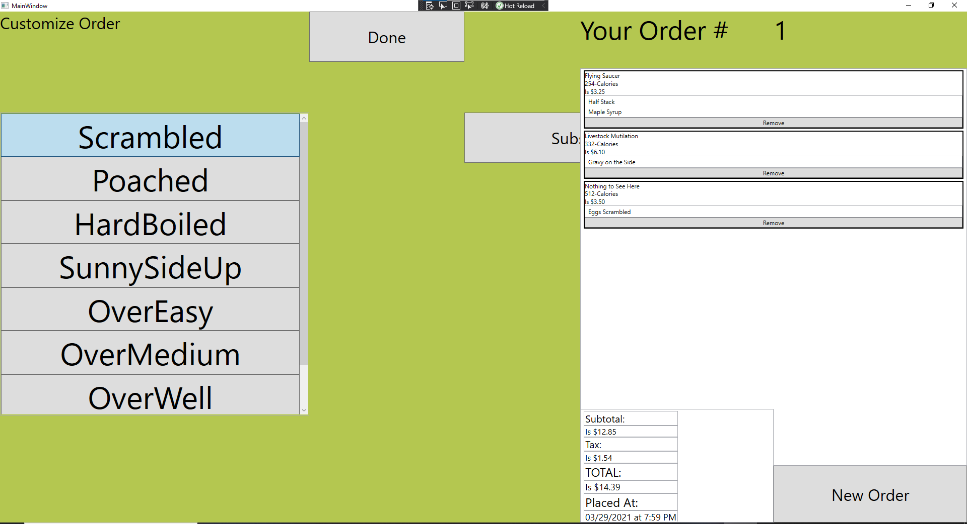

1. Click through each of the egg style options and verify that the special instructions change
2. Click the “Sub” button and verify that “Substitute Sausage” appears on the special instructions of the order.
3. Click the “Done” button to return the Main Menu.
4. Select the “Crashed Saucer” button
5. Verify that your screen looks as follows:

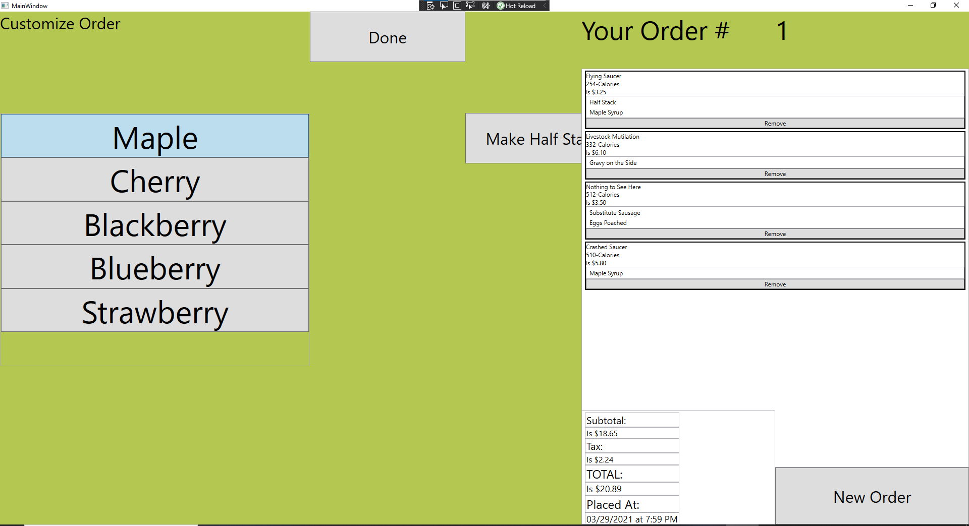

1. Cycle through each of the syrup flavors checking to make sure that this changes the special instructions.
2. Select the Half-Stack option and verify that the following items on the screen change:

-Calories

-Individual item price

-Subtotal

-Tax

-TOTAL

1. Select the “Done” button
2. Click on the “Outer Omelette” button.
3. Verify that your screen looks as follows: 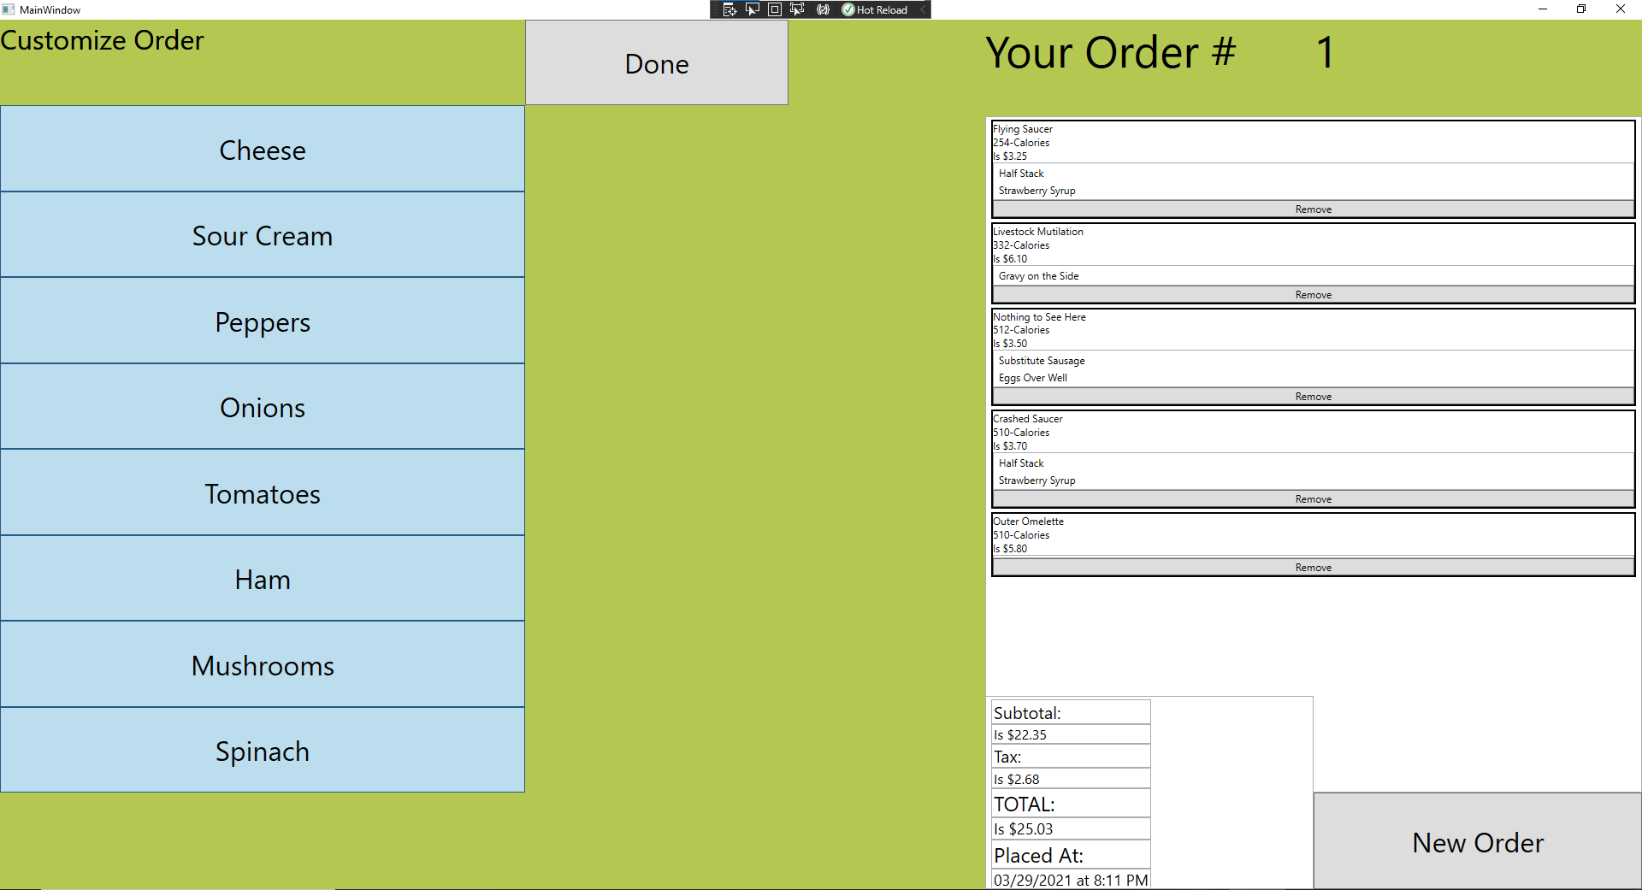
4. Select each of the customization options. Each item should appear as “Hold [item]” and the customization button should be unselected. 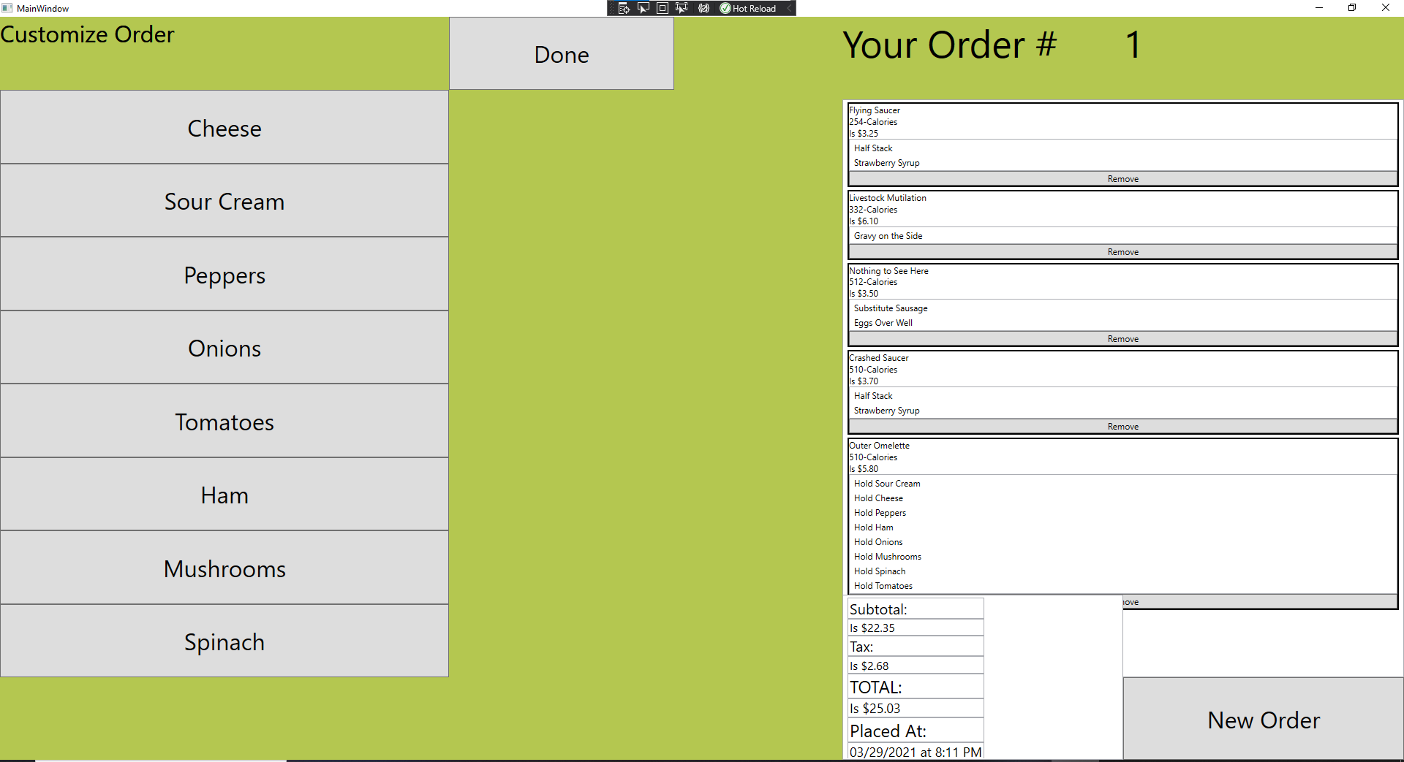
5. Select the “Done” button.
6. Select the “Flying Saucer” order item.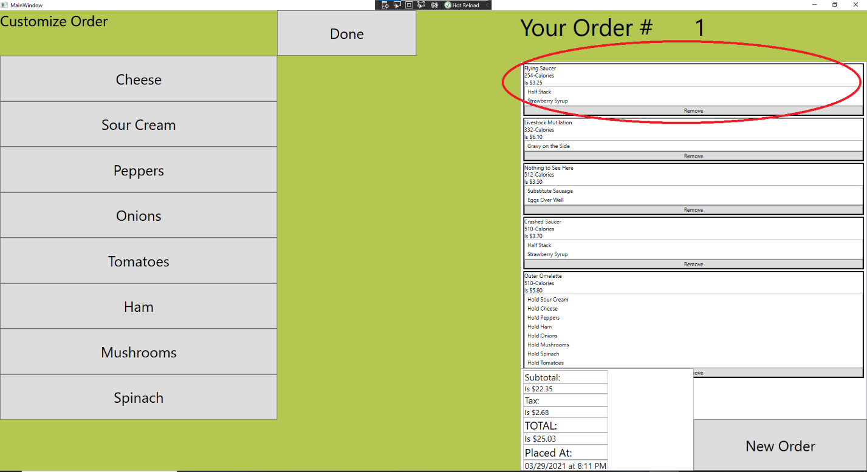
7. You should return to the Flying Saucer customization screen, as such: 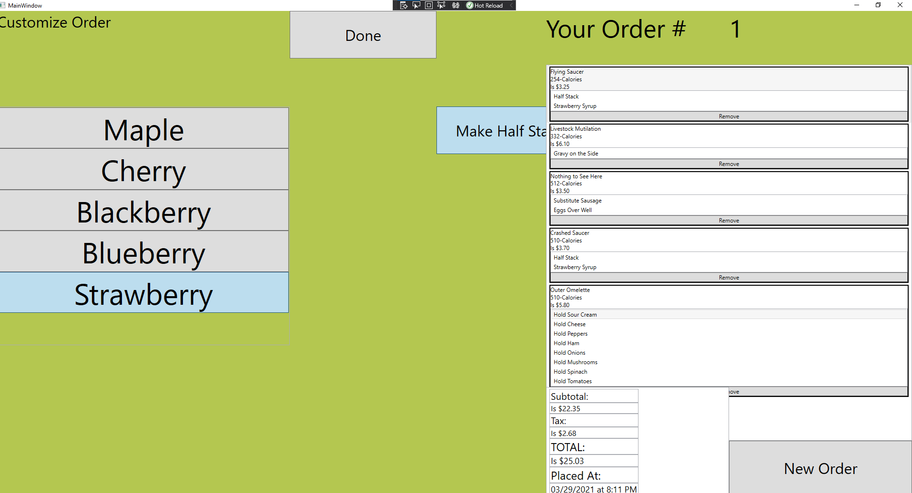
8. Select that the customization options and verify that the order changes appropriately.

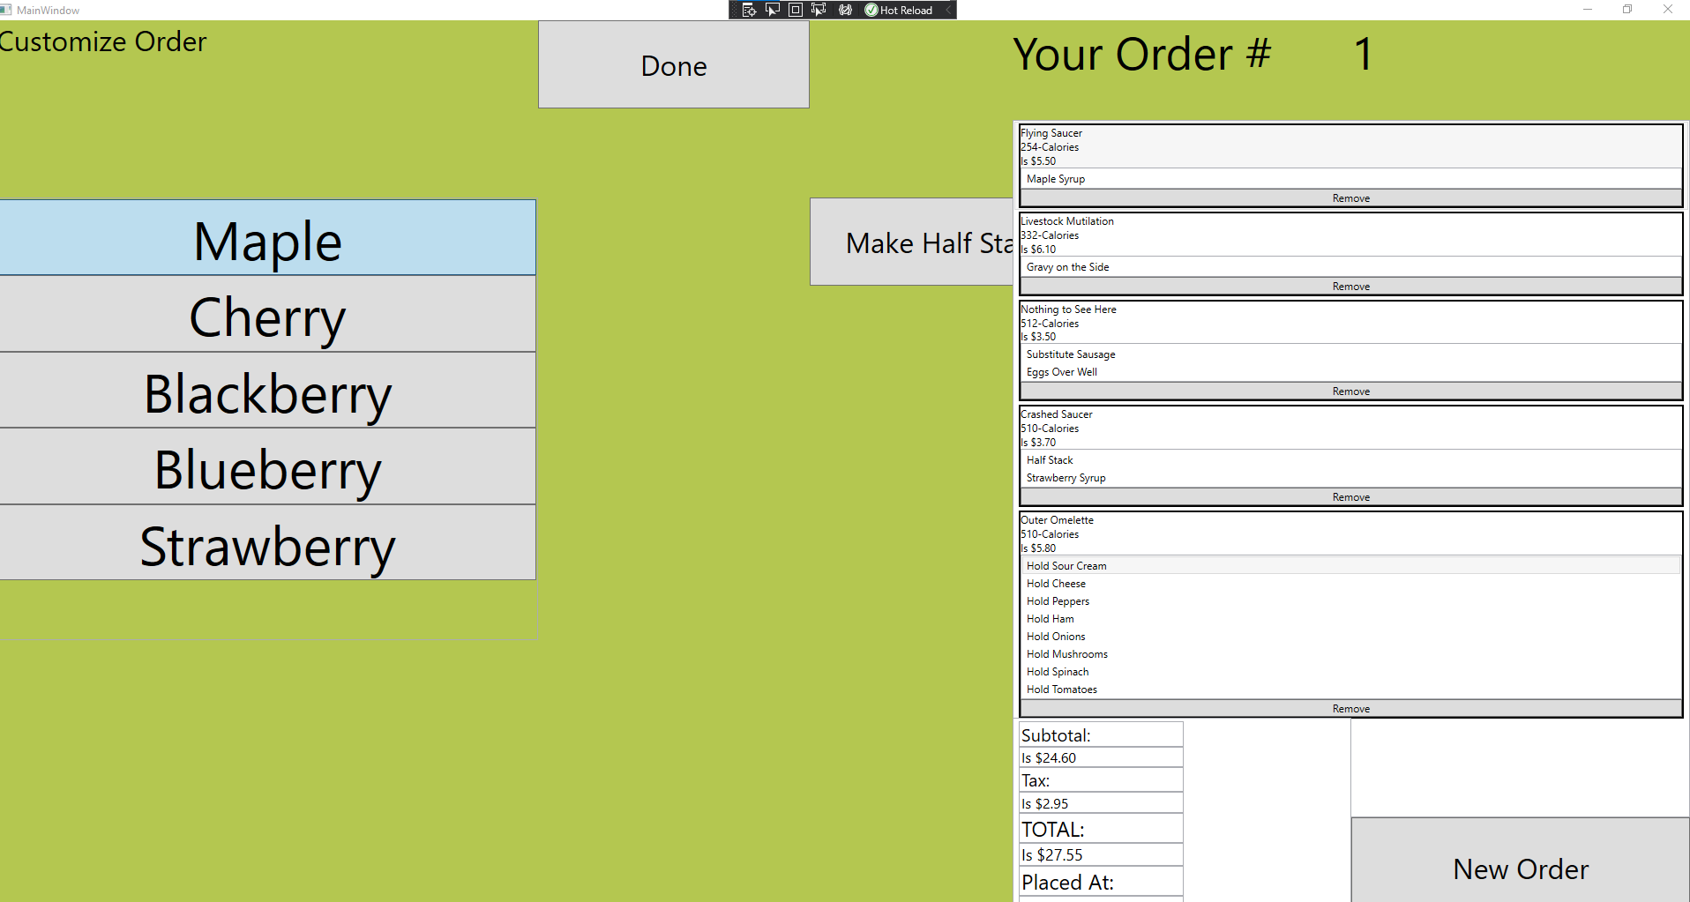

1. Select the “Done” button
2. Repeat steps 25-27 on each of the order items, verifying that you can change the customization options.
3. Select the “Flying Saucer” order item again.
4. Click on the “Remove Button at the bottom of the order item.

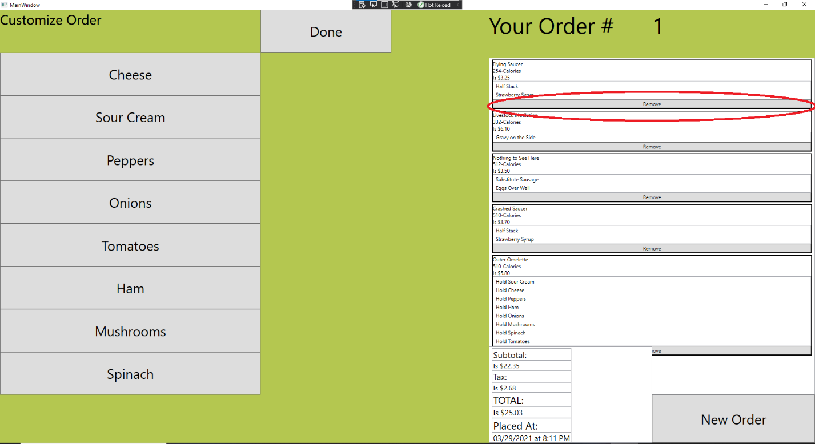

1. Verify that the Flying Saucer order item is no longer on the order.

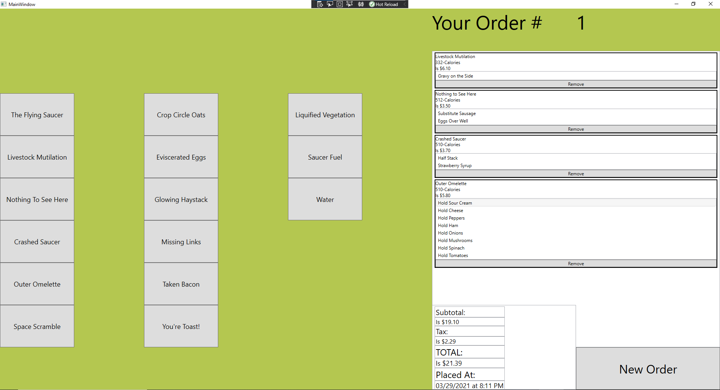

1. Repeat this process with the remaining items on the order menu until the order is clear.

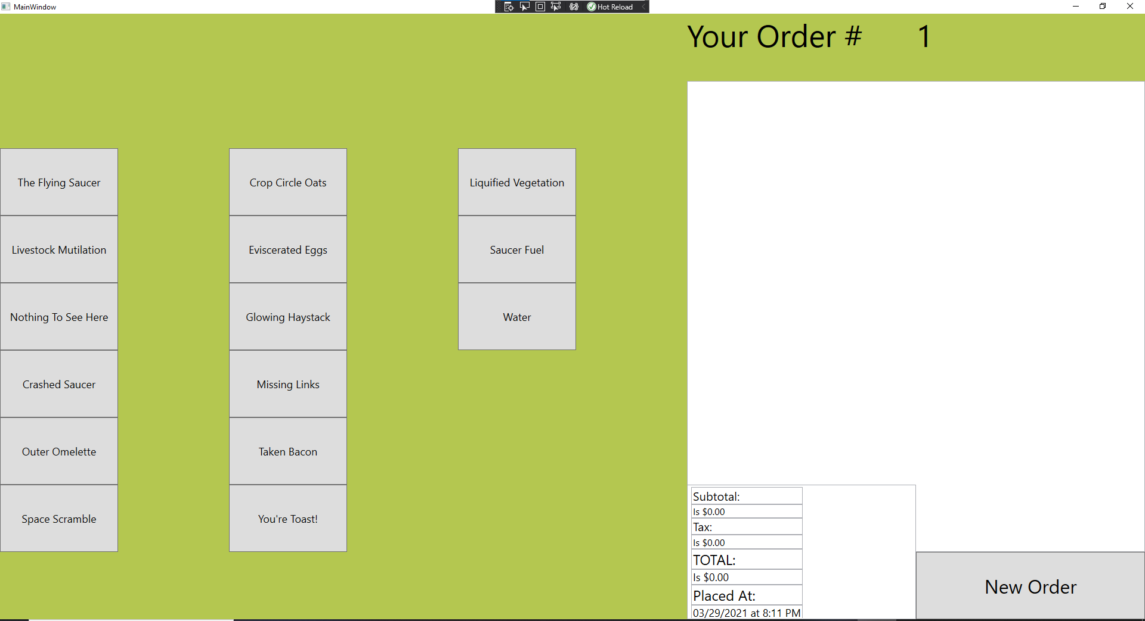

1. Click on the “Crop Circle Oats” button. Verify that the screen appears as follows.

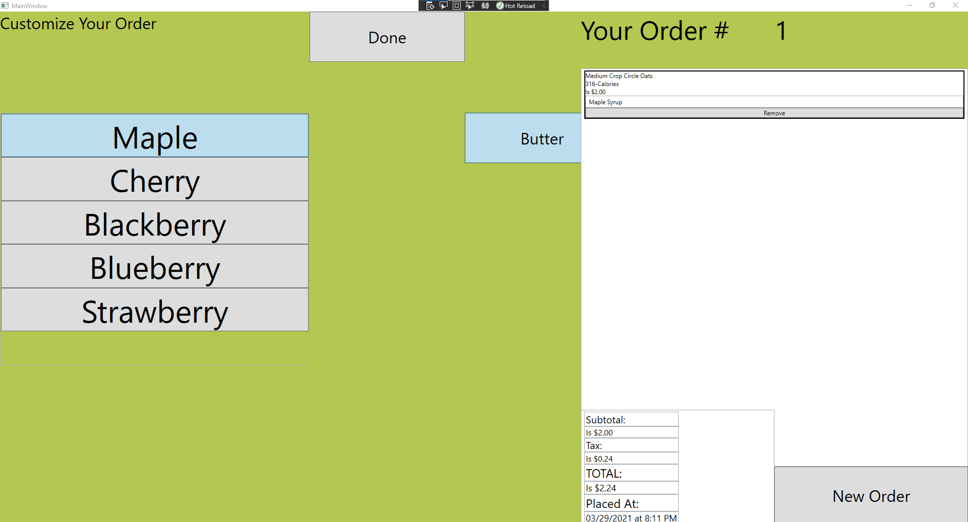

1. Select every customization option and verify that the special instructions are changed. Syrup flavors and “Hold Butter”.
2. Click on the “Done” button to return to the menu.
3. Click on the “Eviscerated Eggs” button and verify that your screen appears as follows:

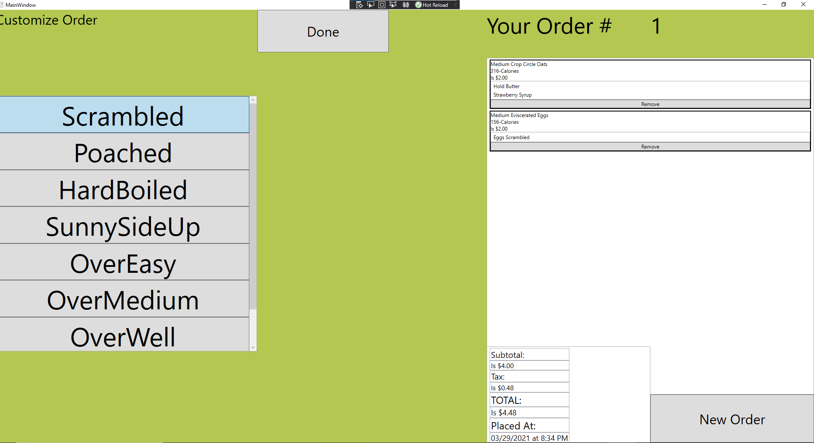

1. Click on each egg style option, verifying that this updates the special instructions.
2. Select the “Done” button to return to the main menu.
3. Click on the “Glowing Haystack” button and verify that your screen looks as follows:

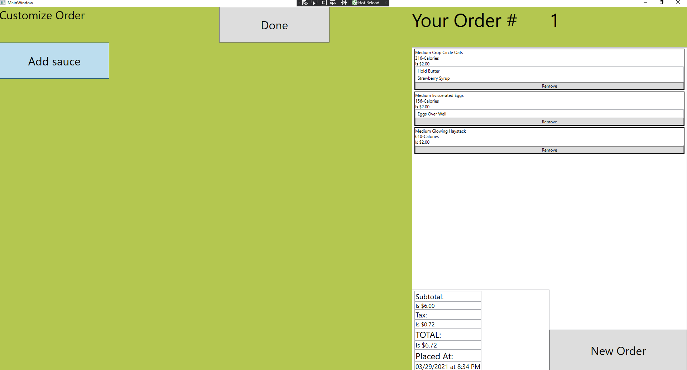

1. Select the “Add Sauce” button and verify that it does **NOT** in fact say “Add Sauce” in the special instructions, but rather “Hold Sauce” as the programmer has been working on this assignment for the last six hours and doesn’t want to change it right now.
2. Click on the “Done” button to return to the main menu.
3. Select the “Missing Links” button and confirm that your screen appears as follows: 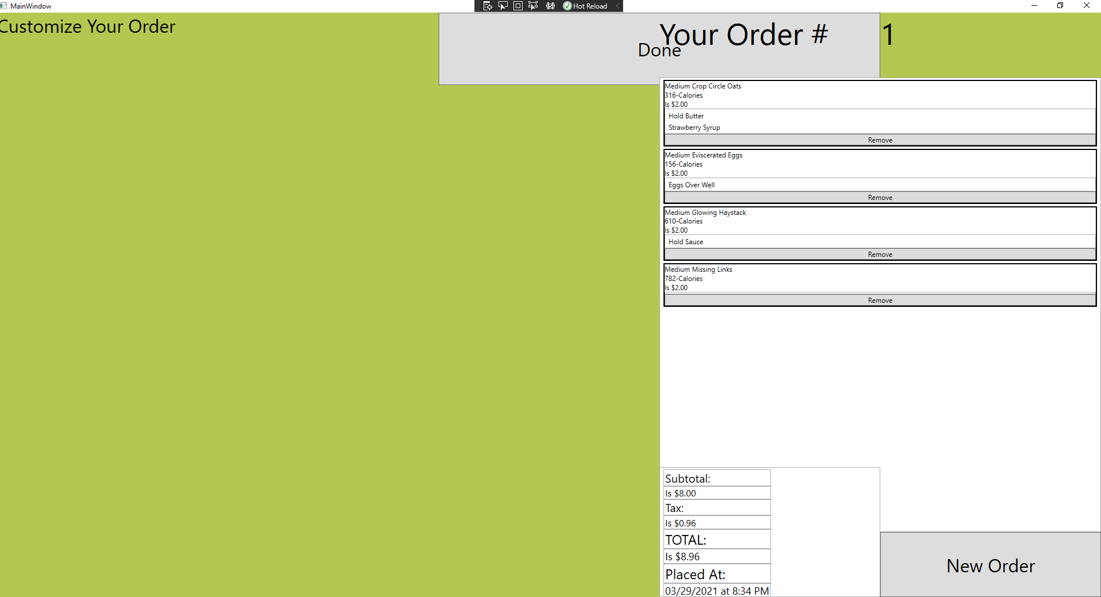
4. Click on the “Done” button to return to the main menu.
5. Select the “Taken Bacon” button and verify that you can see the following:

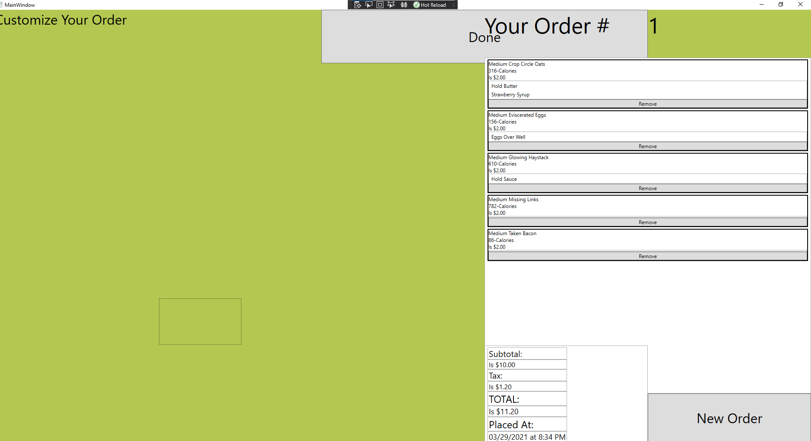

1. Select the “Done” button to return to the main menu.
2. Click on the ‘You’re Toast” option and confirm that your screen is as follows:

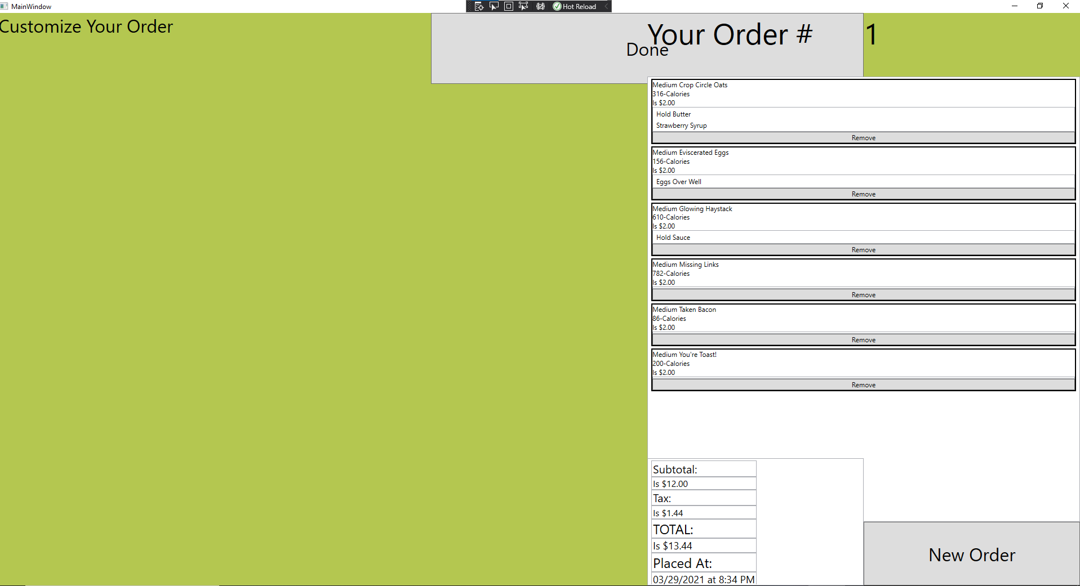

1. Return to the main menu.
2. **Don’t** select the Liquified Vegetation button because your program will crash, and I am too tired to figure out why right now.

**NOTE: If you do this you will probably have to open your task manager and forcibly close Visual Studio.**

1. Select the “Saucer Fuel” button and verify that your screen looks like this:

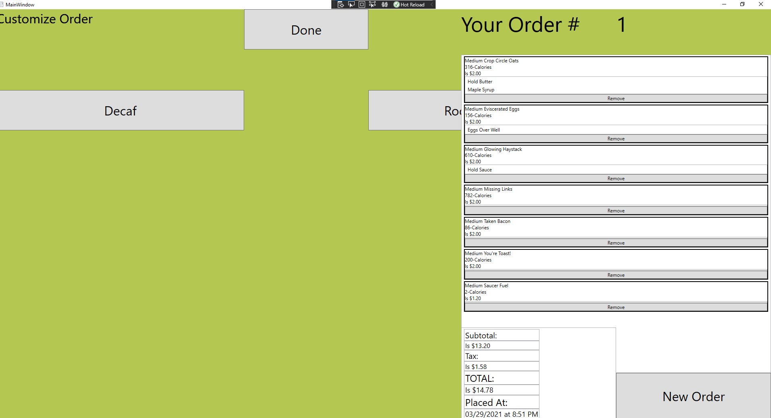

1. Click on the “Decaf” and the “Ro- “buttons and make sure that the special instructions are updated accordingly.
2. Return to the main menu.
3. Remove the saucer fuel menu item to make room for water.
4. Click on the “Water” button. Make sure it looks like this:

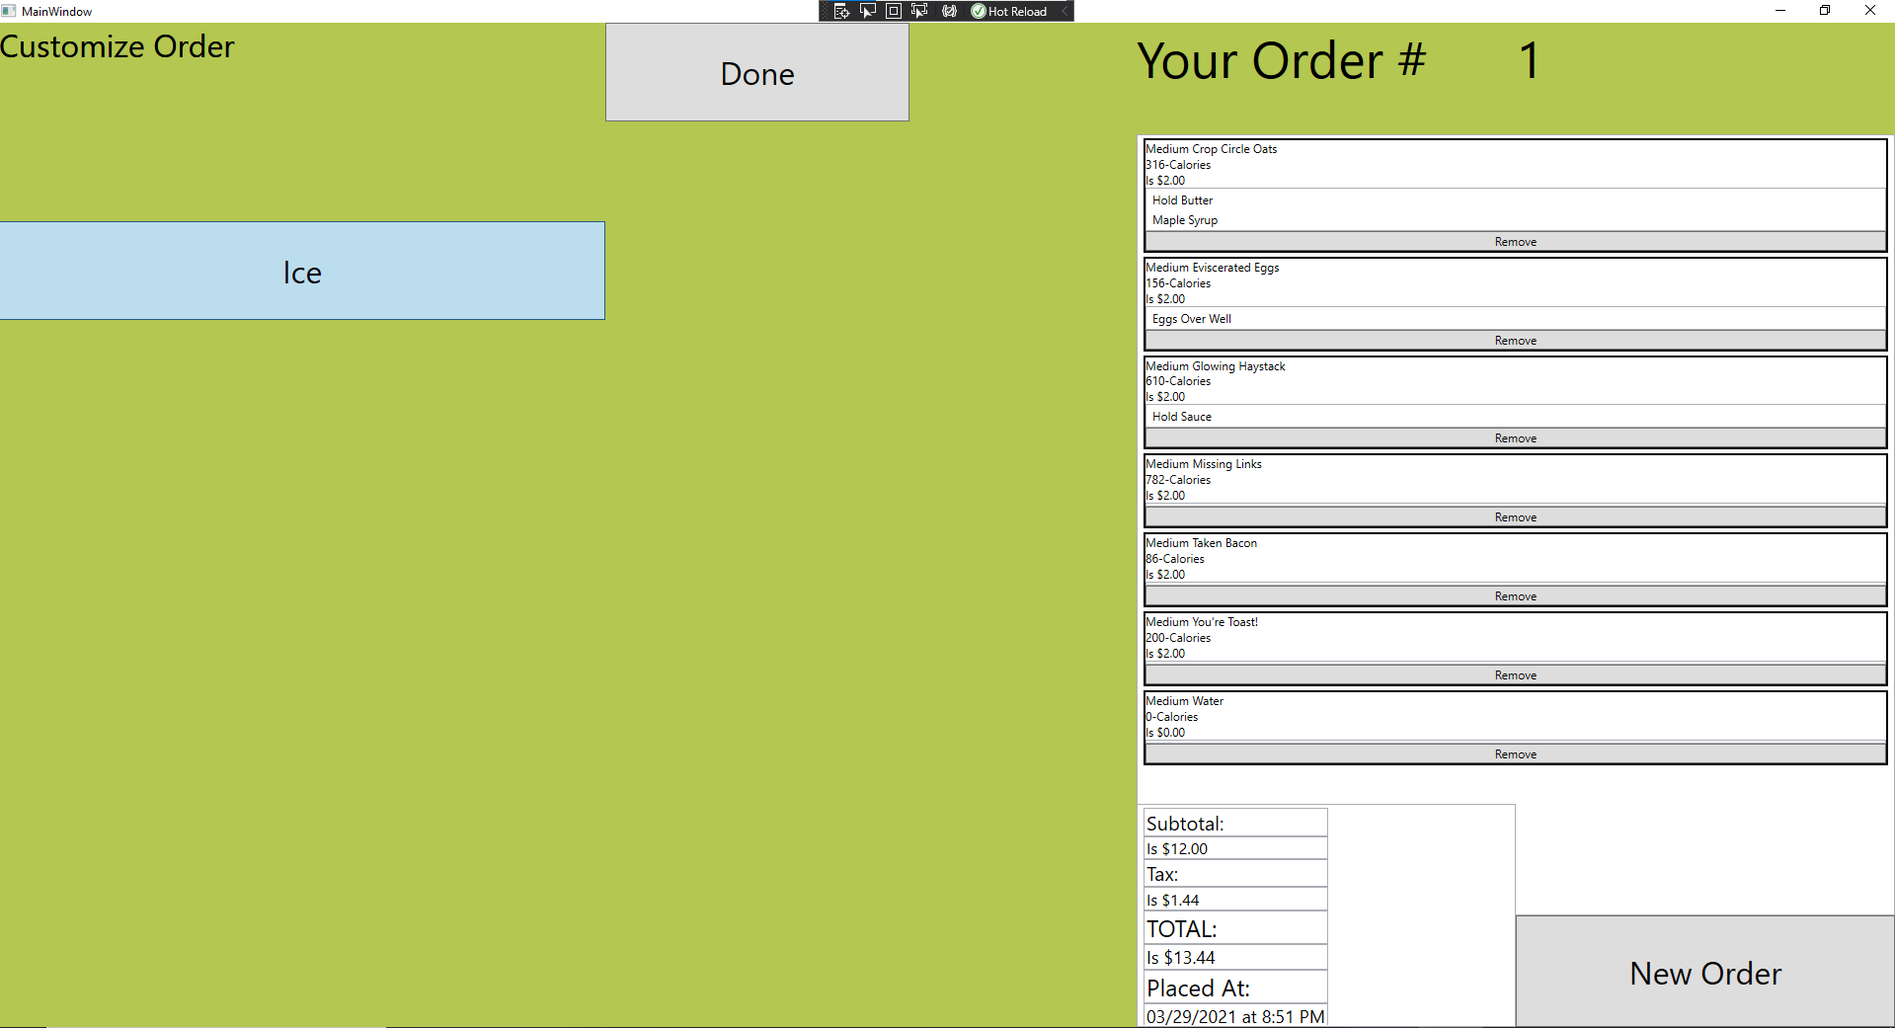

1. Click on ice, look at special instructions. It should say “No Ice.”
2. Click on “Done” to return to the main menu.
3. Select each order item and verify that you can adjust their customization options. (See steps 25-28).
4. Click on the “New Order” button. 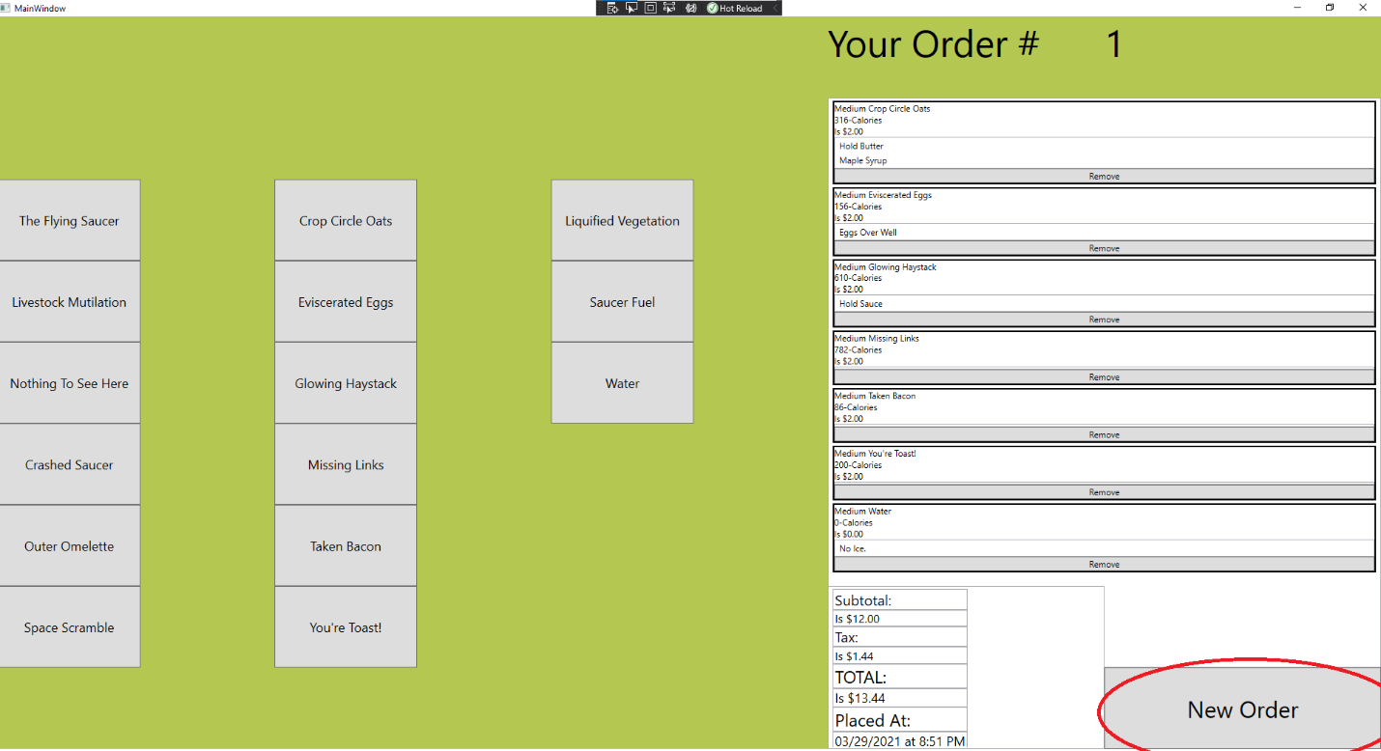
5. Verify that your screen appears as follows.

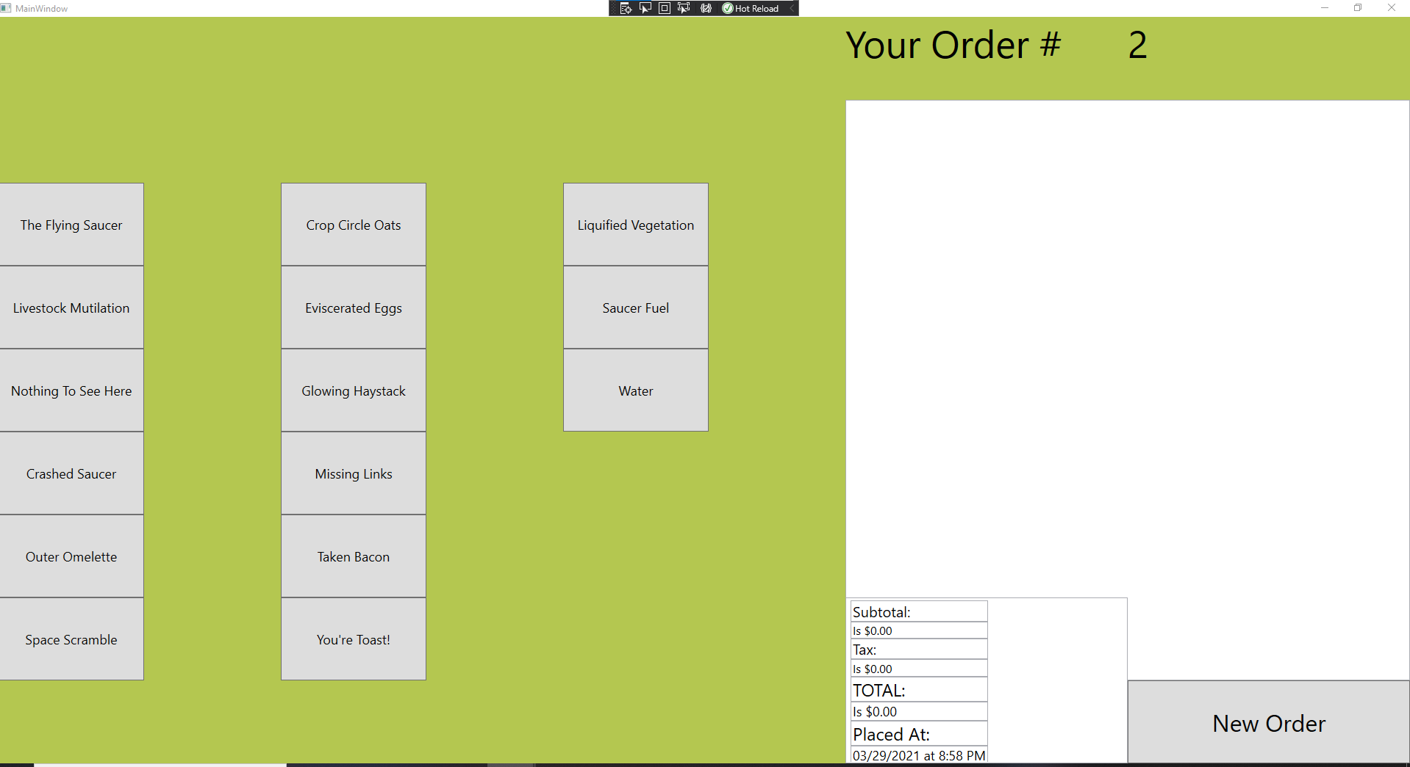

1. Make sure that the “Your Order # “and “Placed At: “items change. 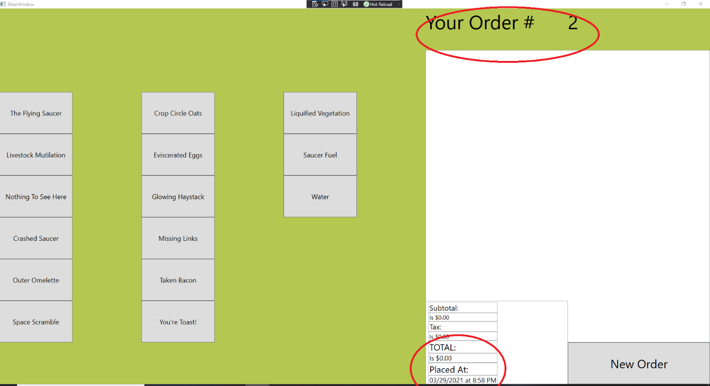

END OF TESTING